QUESTION 1
- g (3) = 2
- g (-1) = 0
- X=0
- Domain (-1,0) (0,1) (3,2)
Range = 3-(-1)
=4

QUESTION 2
V(t)*h(t) = (-10t+5)(-5t2+5t+2.5)

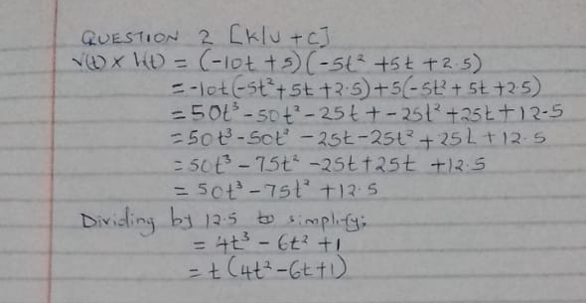

QUESTION 3
F(X) =X3+X2+X+1
= X(X2+X+1)+1
= (X+1)(X2+1)+1
=(X+1) ($\frac{\sqrt{3}}{2}X-1/2)$($\frac{\sqrt{3}}{2}X-1/2)$
=(X+1) ($\frac{\sqrt{3}}{2}X-1/2)$2

QUESTION 4
C(X)= 1.8X2 -14.4X +156.5
The minimum cost is at dc/dx=0
Dc/dx = 3.6x -14.4
3.6x -14.4=0
3.6x = 14.4
X = 4

QUESTION 5
- 5⁻³
=1/(5³)
=1/(5*5*5)
= 1/125

- (-4)⁻²
=1/(-4)²
=1/-4*-4
=1/16

- -3⁻⁴
= 1/-3⁴
= 1/( -3*-3*-3*-3)
= -1/81

QUESTION 6
3cm
4cm
5cm
A
C
B

The three trigonometric ratios are:
Sine
Cosine
Tan
Sin A = 3/5 = 0.6
Cosine A = 4/5 = 0.8
Tan A = ¾ = 0.75
The greatest trigonometric ratio is the cosine.

QUESTION 7
1+Cot ² $θ$ = csc ² $θ$
1+Cot ² $θ$ = 1+ cos ² $θ$/sin ² $θ$
= (sin ² $θ+\cos{2 θ)}$/ sin ² $θ$
1/sin ² $θ=\csc{2 θ}$
